Your thesis has two devices.

* Aquaponics Monitoring
* Power and Switching Monitoring

First, I have made changes in the sensor and circuit for both devices because the one written in your paper is incorrect and incomplete.

I changed the sensor for water level from ultrasonic to water liquid sensor because I do not know the threshold distance of the hardware you had made. The pump will turn on once half of the square part is submerged in water.

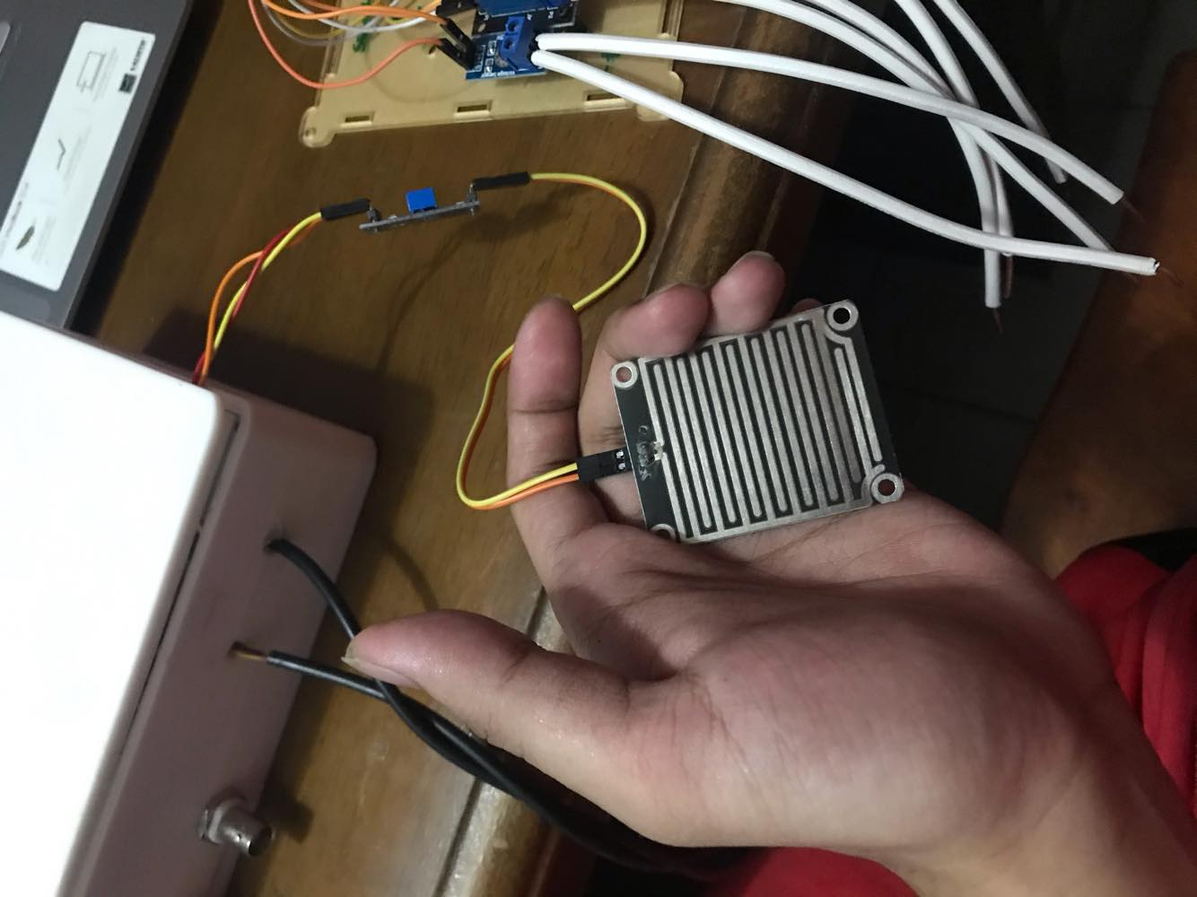

I have changed the circuit of the switching and monitoring system of the Power and Switching Monitor of the device. Just connect the wires together as shown in the picture.

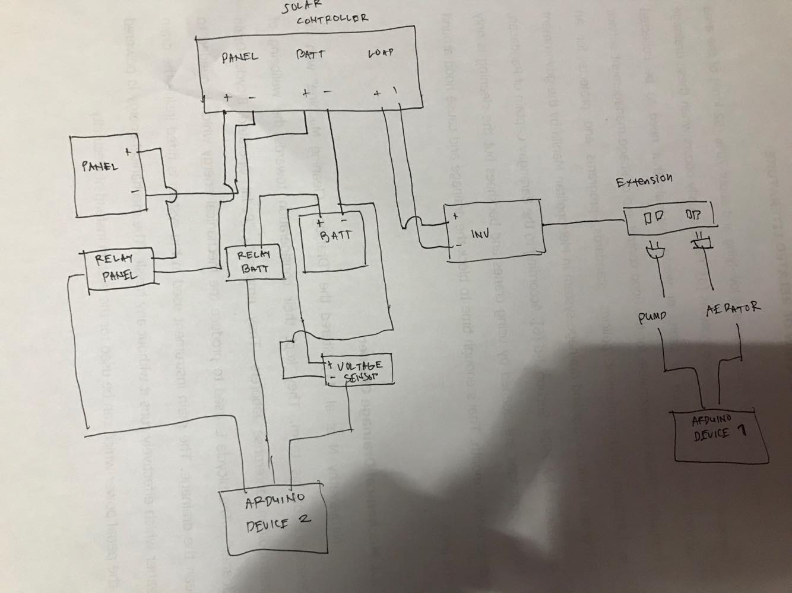

Image of the Prototype

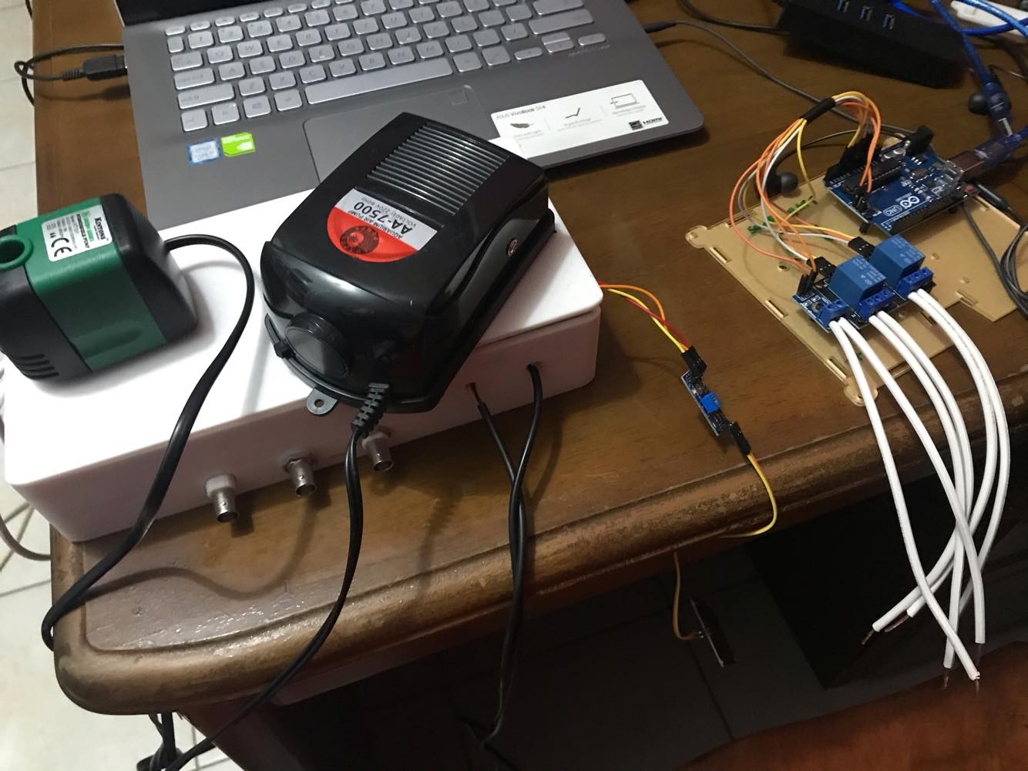

Instruction Manual

Connect first the aquaponics system. Don’t plug the aerator and pump yet.

* Connect the aquaponics device to the PC.
* Open aquaponics_monitor.vi
* Click open file dialog and select the file data_sensors.csv
* Refresh com ports and select the port of the device.
* Run the program.
* Wait for 10 seconds to stabilize and display the program.
* The sensor readings are updated in real time every second and logged into the CSV file so that you may verify it in testing. You mentioned that it should update every minute

See screen shot of instructions on the next page.

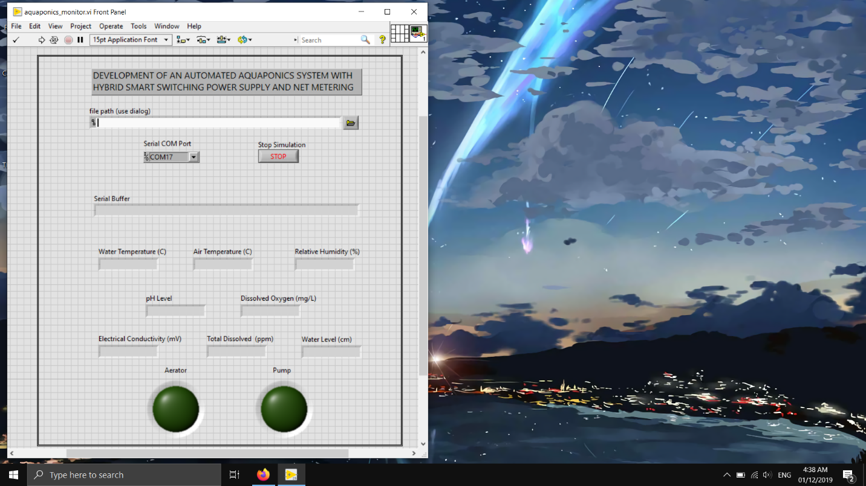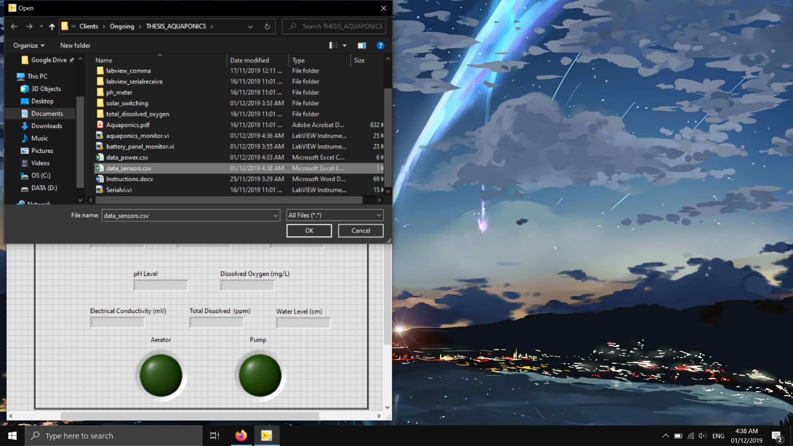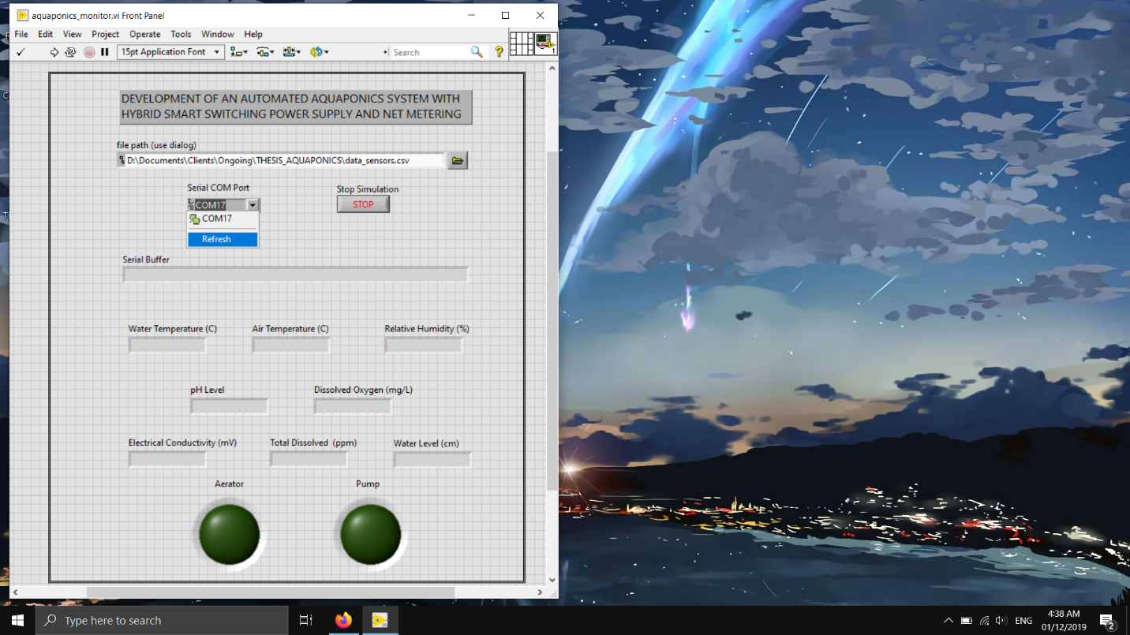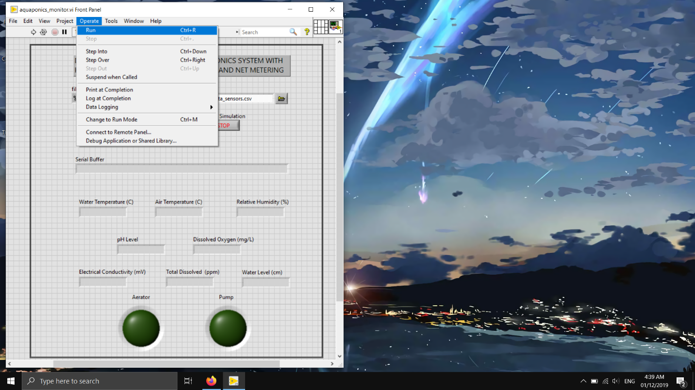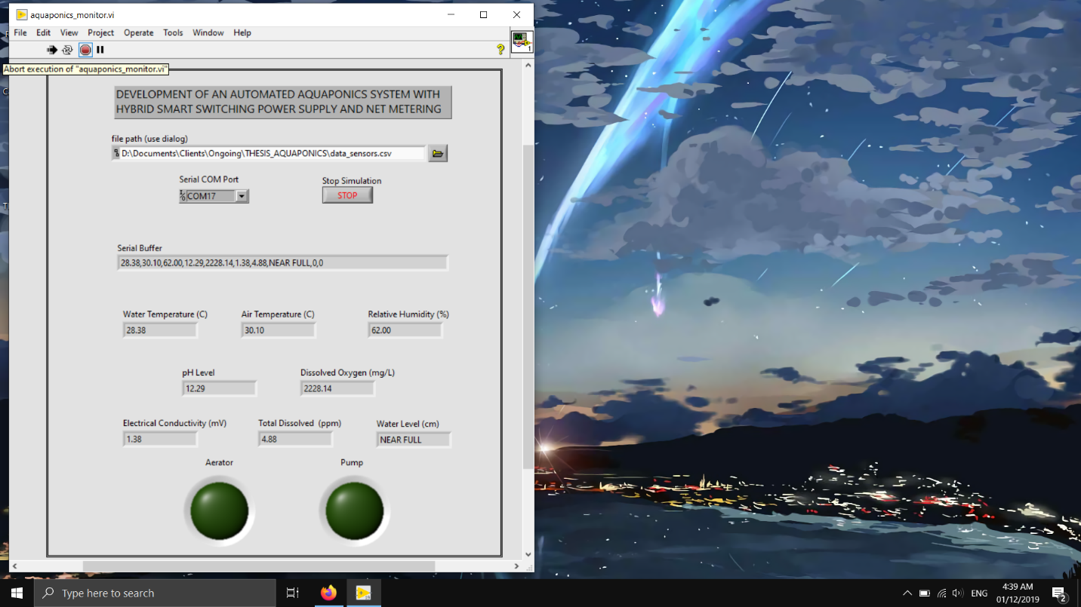

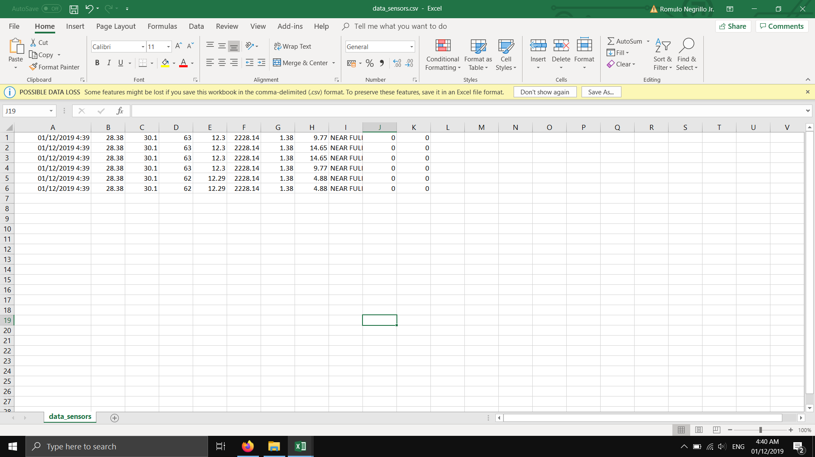

After that connect the second device using the same instruction from the first device except that:

* You should select the data_power.csv in the data logging.
* Select another comport of the new device.

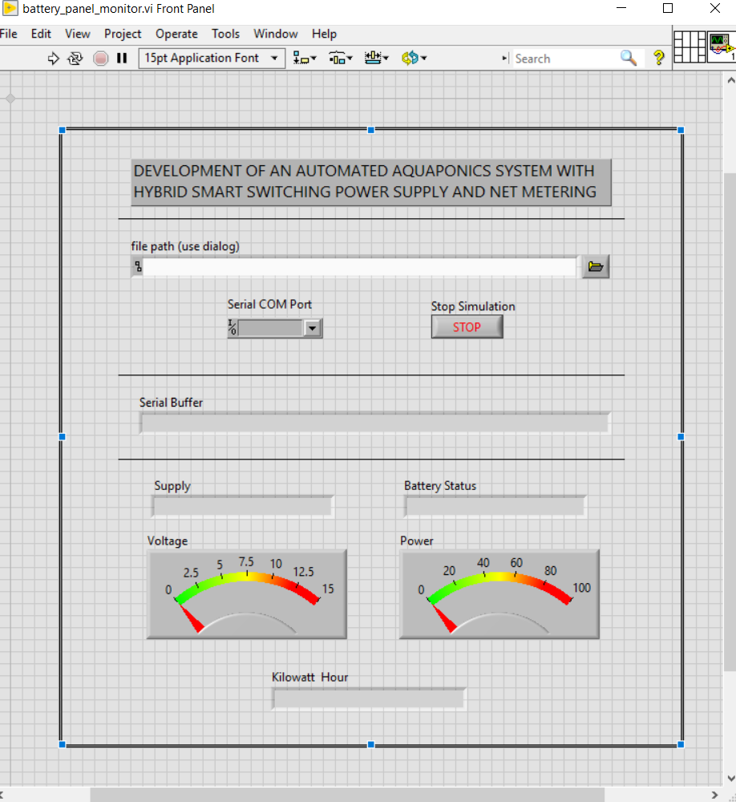



**Notes:**

* Verify first if the GUI is properly connected to the device. See if the data reading changes to verify its connected.
* If the GUI is not updating. Close the program and close the lab view main menu and repeat steps from selecting the CSV file and connecting the port.